DAA ASSIGNMENT – 2
SORTING TECHNIQUES

NAME: KODALI SAHITH
ROLL NO: CH.SC.U4CSE24223
SECTION: CSE-C
DATE: 07-12-2025

- Bubble Sort:

CODE:

#include <stdio.h>

int main() {
int arr[100], n, i, j, temp;

printf("Enter number of elements: ");
scanf("%d", &n);

printf("Enter %d elements:\n", n);
for(i = 0; i < n; i++) {
scanf("%d", &arr[i]);
}

for(i = 0; i < n-1; i++) {
for(j = 0; j < n-i-1; j++) {
if(arr[j] > arr[j+1]) {
temp = arr[j];
arr[j] = arr[j+1];
arr[j+1] = temp;
}
}
}

printf("Sorted array:\n");
for(i = 0; i < n; i++) {
printf("%d ", arr[i]);
}

printf("\n"); // This moves the cursor to the next line
return 0;
}

OUTPUT:

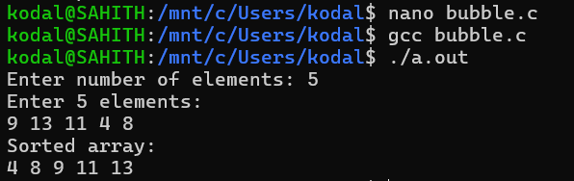

- Selection Sort:

CODE:

#include <stdio.h>

int main() {
int arr[100], n, i, j, min, temp;

printf("Enter number of elements: ");
scanf("%d", &n);

printf("Enter %d elements:\n", n);
for(i = 0; i < n; i++) {
scanf("%d", &arr[i]);
}

// Selection Sort
for(i = 0; i < n-1; i++) {
min = i;
for(j = i+1; j < n; j++) {
if(arr[j] < arr[min]) {
min = j;
}
}

temp = arr[i];
arr[i] = arr[min];
arr[min] = temp;
}

printf("Sorted array:\n");
for(i = 0; i < n; i++) {
printf("%d ", arr[i]);
}

printf("\n");
return 0;
}

OUTPUT:

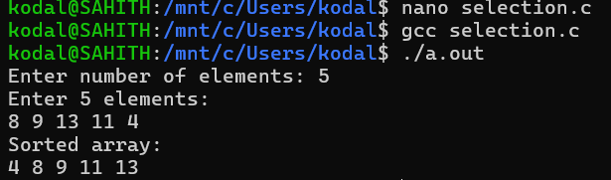

- Insertion Sort:

CODE:

#include <stdio.h>

int main() {
int arr[100], n, i, j, key;

printf("Enter number of elements: ");
scanf("%d", &n);

printf("Enter %d elements:\n", n);
for(i = 0; i < n; i++) {
scanf("%d", &arr[i]);
}

// Insertion Sort
for(i = 1; i < n; i++) {
key = arr[i];
j = i - 1;

while(j >= 0 && arr[j] > key) {
arr[j + 1] = arr[j];
j = j - 1;
}

arr[j + 1] = key;
}

printf("Sorted array:\n");
for(i = 0; i < n; i++) {
printf("%d ", arr[i]);
}

printf("\n");
return 0;
}

OUTPUT:
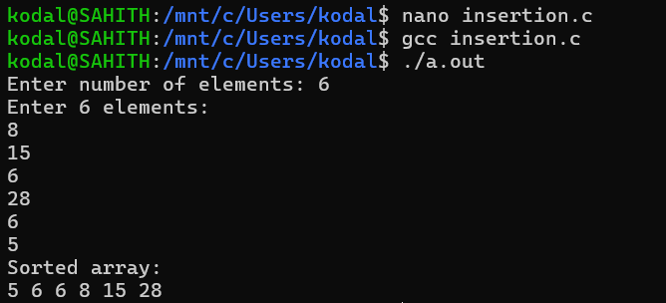

- Heap Sort (Max and Min Heap):

Using Max Heap:

CODE:

#include <stdio.h>

void heapify(int arr[], int n, int i) {
int largest = i;
int left = 2*i + 1;
int right = 2*i + 2;
int temp;

if(left < n && arr[left] > arr[largest])
largest = left;

if(right < n && arr[right] > arr[largest])
largest = right;

if(largest != i) {
temp = arr[i];
arr[i] = arr[largest];
arr[largest] = temp;

heapify(arr, n, largest);
}
}

void heapSort(int arr[], int n) {
int i, temp;

for(i = n/2 - 1; i >= 0; i--)
heapify(arr, n, i);

for(i = n-1; i >= 0; i--) {
temp = arr[0];
arr[0] = arr[i];
arr[i] = temp;

heapify(arr, i, 0);
}
}

int main() {
int arr[100], n, i;

printf("Enter number of elements: ");
scanf("%d", &n);

printf("Enter elements:\n");
for(i=0;i<n;i++)
scanf("%d",&arr[i]);

heapSort(arr,n);

printf("Sorted array:\n");
for(i=0;i<n;i++)
printf("%d ",arr[i]);

printf("\n");
}

OUTPUT:

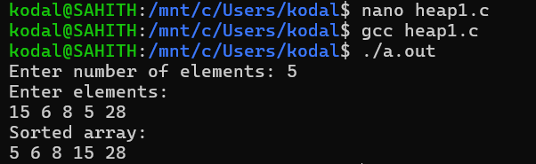

Using Min Heap:

CODE:

#include <stdio.h>

void heapify(int arr[], int n, int i) {
int smallest = i;
int left = 2*i + 1;
int right = 2*i + 2;
int temp;

if(left < n && arr[left] < arr[smallest])
smallest = left;

if(right < n && arr[right] < arr[smallest])
smallest = right;

if(smallest != i) {
temp = arr[i];
arr[i] = arr[smallest];
arr[smallest] = temp;

heapify(arr, n, smallest);
}
}

void heapSort(int arr[], int n) {
int i, temp;

for(i = n/2 - 1; i >= 0; i--)
heapify(arr, n, i);

for(i = n-1; i >= 0; i--) {
temp = arr[0];
arr[0] = arr[i];
arr[i] = temp;

heapify(arr, i, 0);
}
}

int main() {
int arr[100], n, i;

printf("Enter number of elements: ");
scanf("%d",&n);

printf("Enter elements:\n");
for(i=0;i<n;i++)
scanf("%d",&arr[i]);

heapSort(arr,n);

printf("Sorted array (Descending):\n");
for(i=0;i<n;i++)
printf("%d ",arr[i]);

printf("\n");
}

OUTPUT:

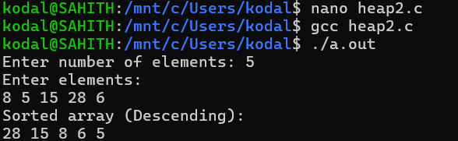

- Bucket Sort:
CODE:

#include <stdio.h>

void bucketSort(int arr[], int n) {
int i, j;
int bucket[10][10], count[10] = {0};

// Put elements into buckets
for(i = 0; i < n; i++) {
int digit = arr[i] / 10; // bucket index
bucket[digit][count[digit]] = arr[i];
count[digit]++;
}

// Sort elements inside each bucket (simple sort)
for(i = 0; i < 10; i++) {
for(j = 0; j < count[i]-1; j++) {
for(int k = j+1; k < count[i]; k++) {
if(bucket[i][j] > bucket[i][k]) {
int temp = bucket[i][j];
bucket[i][j] = bucket[i][k];
bucket[i][k] = temp;
}
}
}
}

// Combine buckets into original array
int index = 0;
for(i = 0; i < 10; i++) {
for(j = 0; j < count[i]; j++) {
arr[index++] = bucket[i][j];
}
}
}

int main() {
int arr[100], n, i;

printf("Enter number of elements: ");
scanf("%d", &n);

printf("Enter elements:\n");
for(i = 0; i < n; i++) {
scanf("%d", &arr[i]);
}

bucketSort(arr, n);

printf("Sorted array:\n");
for(i = 0; i < n; i++) {
printf("%d ", arr[i]);
}

printf("\n");
return 0;
}

OUTPUT:

